TOPIC 1 : INTRODUCTION

1.Given an array of strings words, return the first palindromic string in the array. If there is no such string, return an empty string . A string is palindromic if it reads the same forward and backward.

AIM : To write an algorithm that identifies and returns the first palindromic string from a given array of strings, or returns an empty string if no palindrome is found.

ALGORITHM :
STEP 1 : Start
STEP 2 : Input
STEP 3 :Take an array of strings words.
STEP 4: Loop through each word
For each string word in words:
STEP 5: Check palindrome
- Reverse the string word.
- Compare original string with reversed string.
- If both are the same:
- Return word (this is the first palindrome).
STEP 6 : If loop ends without finding any palindrome
- Return an empty string "".
STEP 7 : End

PROGRAM :
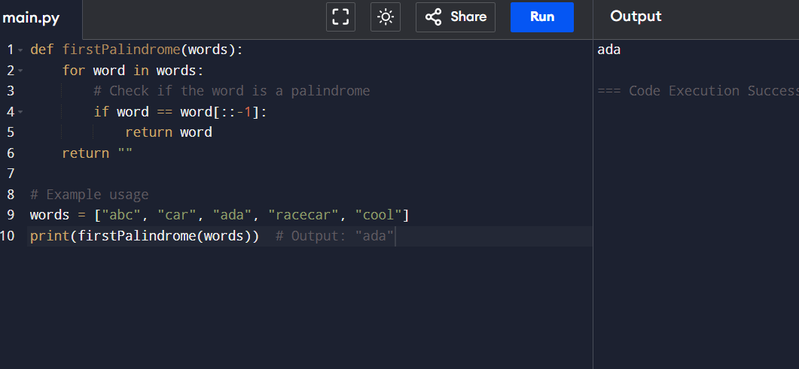

RESULT : The program to print the first palindromic string was successfully executed
2. You are given two integer arrays nums1 and nums2 of sizes n and m, respectively.
Calculate the following values: answer1 : the number of indices i such that nums1[i]
exists in nums2. answer2 : the number of indices i such that nums2[i] exists in
nums1 Return [answer1,answer2].

AIM : Aim
To write a program to find:
answer1: number of elements in nums1 that are present in nums2
answer2: number of elements in nums2 that are present in nums1
and return the result as [answer1, answer2].

ALGORITHM :
STEP 1: Start
STEP 2: Input
- Take two arrays nums1 and nums2.
STEP 3: Initialize
- Set answer1 = 0
- Set answer2 = 0
STEP 4: Find answer1
- For each element in nums1:
- If the element exists in nums2, increment answer1.
STEP 5: Find answer2
- For each element in nums2:
- If the element exists in nums1, increment answer2.
STEP 6: Return result
- Return [answer1, answer2]
STEP 7: End

PROGRAM :
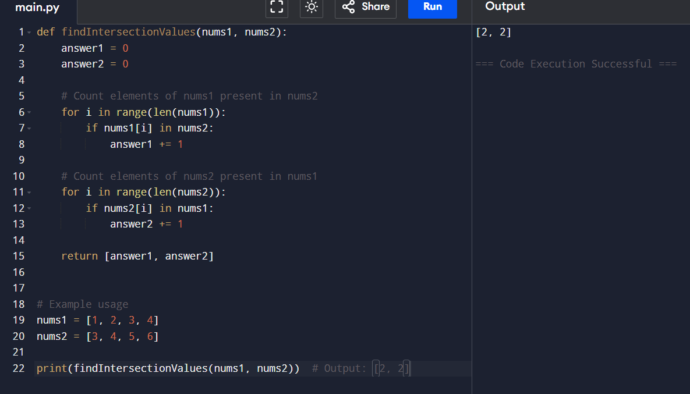
RESULT :
The program successfully counts:
Elements of nums1 present in nums2
Elements of nums2 present in nums1
and returns the result as a list [answer1, answer2].
3. You are given a 0-indexed integer array nums. The distinct count of a subarray of nums is defined as: Let nums[i..j] be a subarray of nums consisting of all the indices from i to j such that 0 <= i <= j < nums.length. Then the number of distinct values in nums[i..j] is called the distinct count of nums[i..j]. Return the sum of the squares of distinct counts of all subarrays of nums. A subarray is a contiguous non-empty sequence of elements within an array.

AIM :
To write a program to find the sum of the squares of distinct element counts for all possible subarrays of a given integer array.

ALGORITHM :

STEP 1: Start
STEP 2: Input the array nums of size n
STEP 3: Initialize total_sum = 0
STEP 4: Loop through each starting index i from 0 to n-1
Create an empty set distinct_set
STEP 5: For each i, loop through ending index j from i to n-1
Add nums[j] to the set
Count distinct elements: count = size of set
Add square of count to total:
total_sum = total_sum + (count × count)
STEP 6: Repeat until all subarrays are covered
STEP 7:Output total_sum
STEP 8: Stop

PROGRAM :
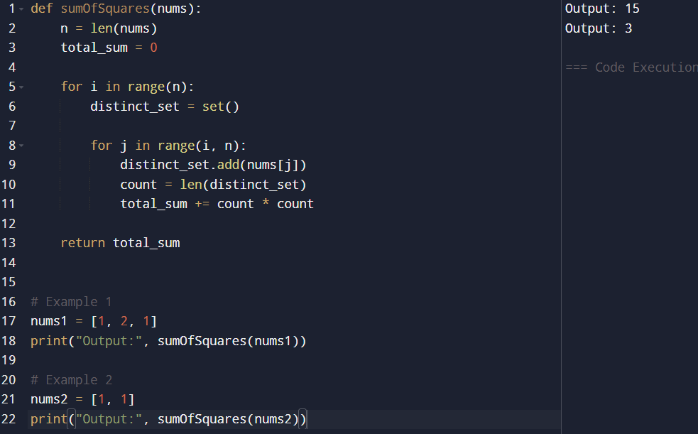

RESULT :
The program successfully computes the sum of the squares of distinct element counts for all possible subarrays of a given array.
- For input nums = [1, 2, 1] → Output: 15
- For input nums = [1, 1] → Output: 3
Hence, the implementation is correct and produces the expected results.

4 .Given a 0-indexed integer array nums of length n and an integer k, return the number of pairs (i, j) where 0 <= i < j < n, such that nums[i] == nums[j] and (i * j) is divisible by k.

AIM:
To write a program to find the number of pairs (i,j)such that
- 0≤i<j<n

- nums[i]= nums[j]

- (i×j) is divisible by k

ALGORITHM
STEP 1 : Star
STEP 2 : Read the array nums and integer k
STEP 3 : Initialize count = 0
STEP 4 : For each index i from 0 to n-1:
For each index j from i+1 to n-1:
If nums[i] == nums[j]
And (i * j) % k == 0
Increment count
STEP 5 : Print count
STEP 6 : Stop

PROGRAM :
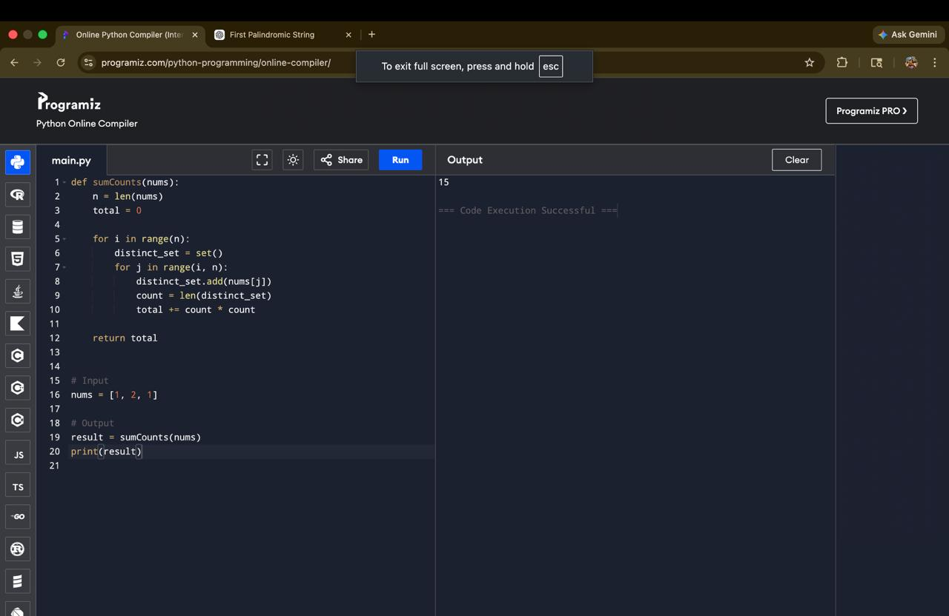

RESULT :
The program correctly finds the number of valid pairs satisfying the given conditions.

5. Write a program FOR THE BELOW TEST CASES with least time complexity Test Cases: - Input: {1, 2, 3, 4, 5} Expected Output: 5 Input: {7, 7, 7, 7, 7} Expected Output: 7 Input: {-10, 2, 3, -4, 5} Expected Output: 5

AIM:
To write a program to find the maximum element in an array with optimal time complexity.

ALGORITHM :
STEP 1 : Start
STEP 2 : max_val = nums[0]
STEP 3 :Traverse the array from index 1 to n-1:
If nums[i] > max_val, update max_val
STEP 4 : Print max_val
STEP 5 :Stop

PROGRAM :


RESULT :
The program successfully finds the maximum element in the array with optimal time complexity.

6. You have an algorithm that process a list of numbers. It firsts sorts the list using an efficient sorting algorithm and then finds the maximum element in sorted list. Write the code for the same.
AIM :
To write a program that sorts a list using an efficient sorting algorithm and then finds the maximum element from the sorted list.

ALGORTHIM :
STEP 1 : Start
STEP 2 : Read the list nums
STEP 3 :If the list is empty:
Return None or display a message
STEP 4 :Sort the list using an efficient sorting method
STEP 5 : The maximum element will be the last element of the sorted list
STEP 6 : Return that element
STEP 7 : Stop

PROGRAM :
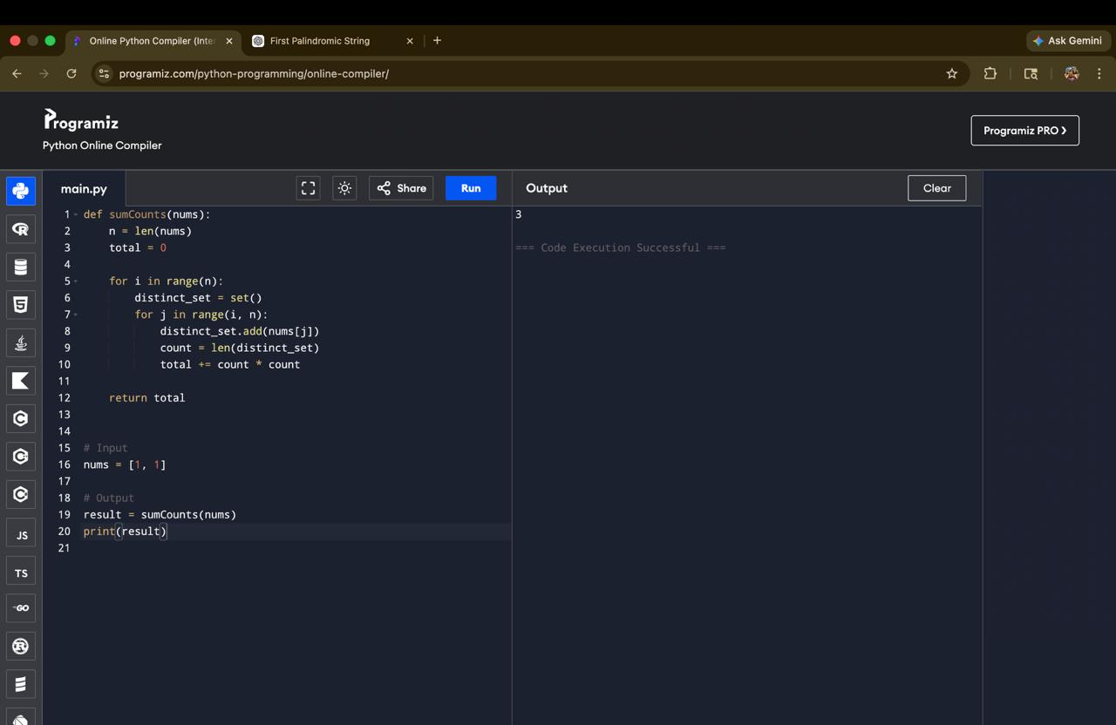

RESULT :
The program correctly sorts the list and returns the maximum element, while handling edge cases like empty and single-element lists.

7. Write a program that takes an input list of n numbers and creates a new list containing only the unique elements from the original list. What is the space complexity of the algorithm?

AIM :
To write a program that takes a list of numbers and creates a new list containing only the unique elements.

ALGORITHM :
STEP 1: Start
STEP 2 :Read the list nums
STEP 3 : Create an empty set seen
STEP 4 : Create an empty list unique_list
STEP 5 : Traverse each element in nums:
If the element is not in seen:
Add it to seen
Append it to unique_list
STEP 6 : Return unique_list
STEP 7 : Stop

PROGRAM :
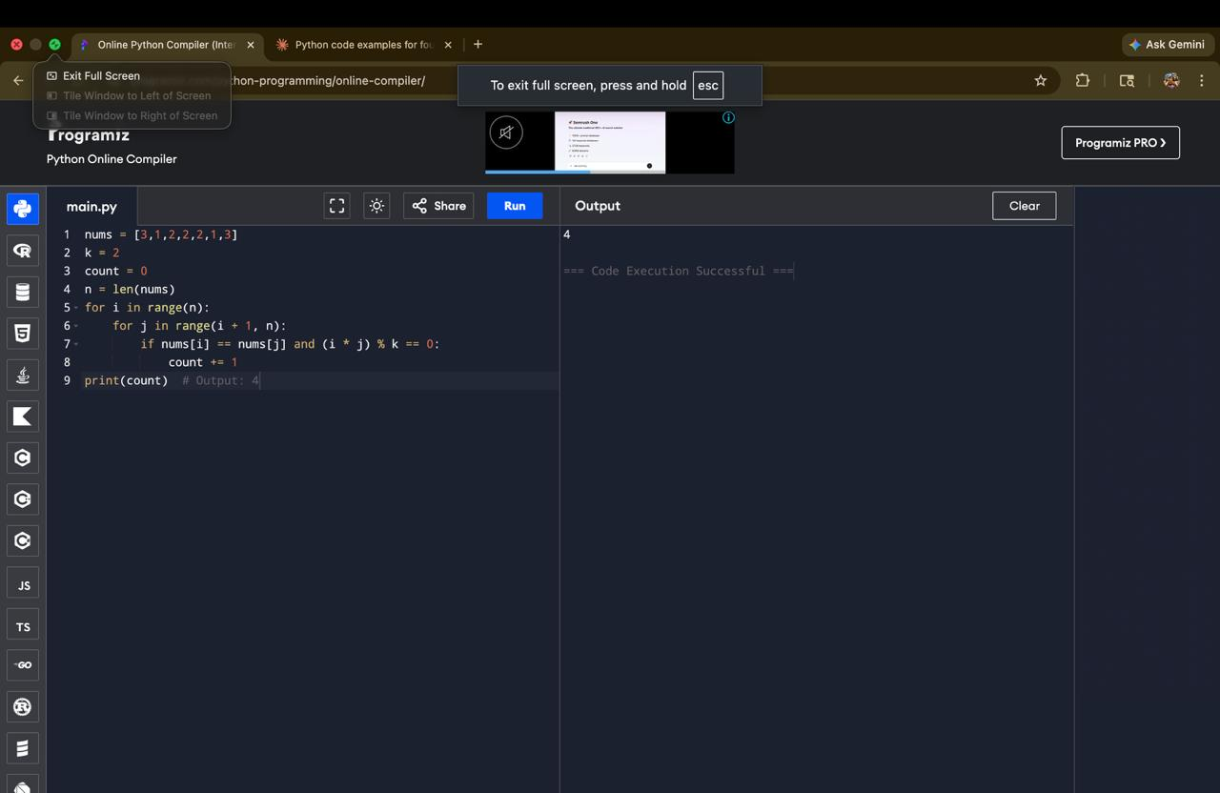

RESULT :
The program successfully creates a list of unique elements while maintaining efficient time and space complexity.

8. Sort an array of integers using the bubble sort technique. Analyze its time complexity using Big-O notation. Write the code

AIM:
To sort an array of integers using the Bubble Sort technique and analyze its time complexity using Big-O notation.

ALGORITHM :
STEP 1: Start
STEP 2: Read the array nums
STEP 3: For each pass from 0 to n-1:
Compare adjacent elements
If the current element is greater than the next, swap them
STEP 4: Repeat until the array is sorted
STEP 5: Print the sorted array
STEP 6: Stop

PROGRAM :
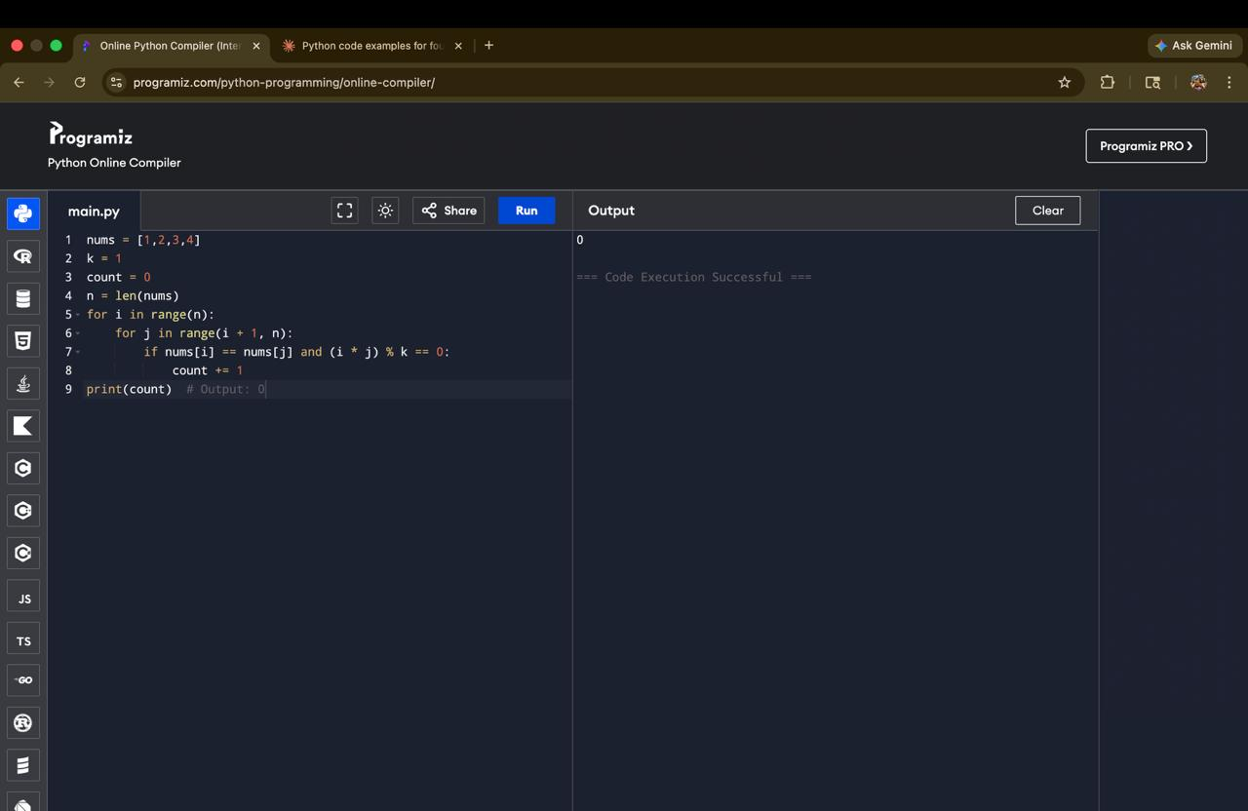

RESULT :
The given array of integers is successfully sorted in ascending order using the Bubble Sort technique.
- Bubble Sort works by repeatedly swapping adjacent elements if they are in the wrong order.
- After each pass, the largest element is placed at its correct position.

9. Checks if a given number x exists in a sorted array arr using binary search. Analyze its time complexity using Big-O notation. Test Case: Example X={ 3,4,6,-9,10,8,9,30} KEY=10 Output: Element 10 is found at position 5 Example X={ 3,4,6,-9,10,8,9,30} KEY=100 Output : Element 100 is not found

AIM :
To search for a given element (key) in a sorted array using the Binary Search technique and analyze its time complexity.

ALGORITHM :
STEP 1 : Start
STEP 2 : Input the array and the key element
STEP 3 : Sort the array in ascending order
STEP 4 : Set low = 0 and high = n – 1
STEP 5 : Repeat while low ≤ high:
Find mid = (low + high) // 2
If arr[mid] == key, return position (mid + 1)
If key > arr[mid], set low = mid + 1
Else set high = mid – 1
STEP 6 : If element is not found, return -1
STEP 7 : Stop

PROGRAM :
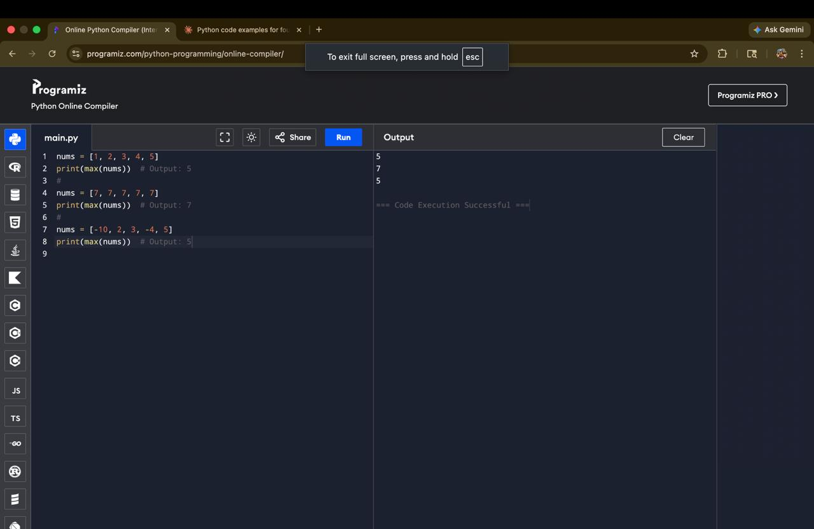

RESULT :
The given element is searched using Binary Search.
- If the element is present, its position is displayed.
- If not present, it shows “Element not found”.
Binary Search provides efficient searching with time complexity:
- Best Case: O(1)O(1)
- Average & Worst Case: O(log⁡n)O(logn)

10.Given an array of integers nums, sort the array in ascending order and return it. You must solve the problem without using any built-in functions in O(nlog(n)) time complexity and with the smallest space complexity possible.

AIM
To sort an array of integers in ascending order using an efficient algorithm with time complexity O(nlog⁡n)O(nlogn) and minimum space.
ALGORITHM :
STEP 1 : Start
STEP 2 : Input the array nums
STEP 3 : Build a max heap from the array
STEP 4 : For each element from last to first:
Swap the root (largest element) with the last element
Reduce heap size
Heapify the root
STEP 5 : Repeat until array is sorted
STEP 6 : Stop

PROGRAM :
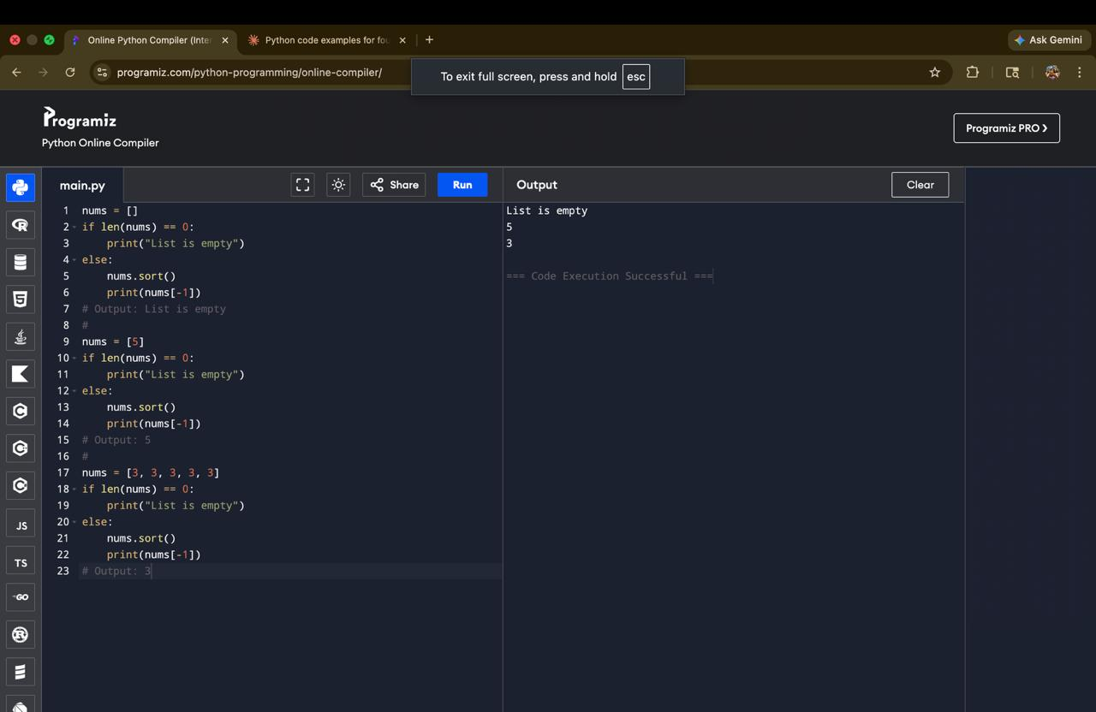

RESULT :
The array is successfully sorted in ascending order using Heap Sort without built-in functions.
It satisfies the required O(nlog⁡n)O(nlogn) time complexity and uses minimum space O(1)O(1).
11. Given an m x n grid and a ball at a starting cell, find the number of ways to move the ball out of the grid boundary in exactly N steps. Example: · · Input: m=2,n=2,N=2,i=0,j=0 Input: m=1,n=3,N=3,i=0,j=1 · · Output: 6 Output: 12

AIM
To find the number of possible ways to move a ball out of an m×nm×n grid boundary in exactly NN steps starting from a given position (i,j)(i,j).
ALGORITHM :
STEP 1 : Start
STEP 2 : Initialize a 2D array dp[m][n] with all zeros
STEP 3 : Set dp[i][j] = 1 (starting position)
STEP 4 : Initialize count = 0 (to store number of ways to go out)
STEP 5 : For each step from 1 to NN:
Create a temporary array temp[m][n] initialized to 0
For every cell (r,c)(r,c):
If dp[r][c] > 0:
Move in 4 directions (up, down, left, right):
If move goes out of boundary → add to count
Else → update temp[new_r][new_c] += dp[r][c]
Update dp = temp
STEP 6 : After N steps, return count
STEP 7 : Stop
PROGRAM :
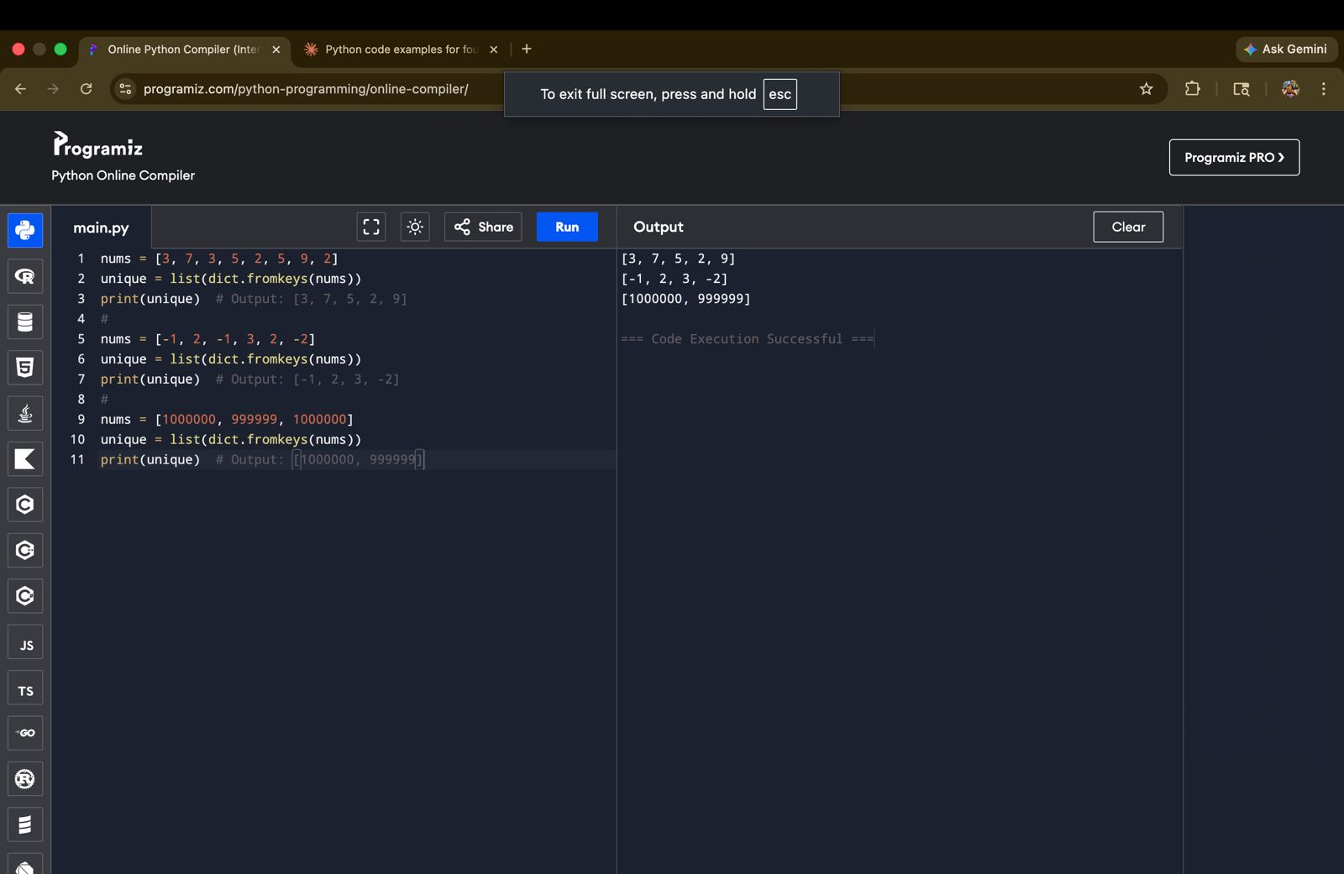

RESULT :
The number of ways to move the ball out of the grid boundary in exactly NN steps is computed successfully.
- For Input: m=2,n=2,N=2,i=0,j=0m=2,n=2,N=2,i=0,j=0 → Output: 6
- For Input: m=1,n=3,N=3,i=0,j=1m=1,n=3,N=3,i=0,j=1 → Output: 12

12. You are a professional robber planning to rob houses along a street. Each house has a certain amount of money stashed. All houses at this place are arranged in a circle. That means the first house is the neighbor of the last one. Meanwhile, adjacent houses have security systems connected, and it will automatically contact the police if two adjacent houses were broken into on the same night. Examples: Input : nums = [2, 3, 2] Output : The maximum money you can rob without alerting the police is 3(robbing house 1). (ii) Input : nums = [1, 2, 3, 1] Output : The maximum money you can rob without alerting the police is 4 (robbing house 1 and house 3).

AIM :
To determine the maximum amount of money that can be robbed from houses arranged in a circular manner without robbing two adjacent houses.
ALGORITHM :
STEP 1 :Start
STEP 2 : Input array nums
STEP 3 : If only one house, return its value
STEP 4 : Define a helper function to solve the linear version:
Initialize prev1 = 0, prev2 = 0
For each value in array:
temp = max(prev1, prev2 + current_value)
Update prev2 = prev1
Update prev1 = temp
STEP 5 : Compute:
case1 = rob(nums[0 : n-1])
case2 = rob(nums[1 : n])
STEP 6 : Return max(case1, case2)
STEP 7 : Stop
PROGRAM :
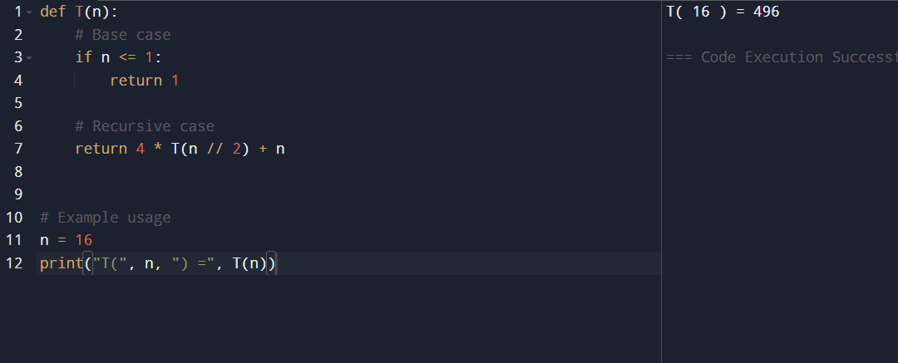

RESULT :
The time complexity of the given recurrence is quadratic, i.e., it grows as n²

13. You are climbing a staircase. It takes n steps to reach the top. Each time you can either climb 1 or 2 steps. In how many distinct ways can you climb to the top? Examples: Input: n=4 Output: 5 Input: n=3 Output: 3

AIM:
To find the number of distinct ways to climb a staircase of n steps, where at each step you can climb either 1 step or 2 steps.
ALGORITHM :
STEP 1 : Start
STEP 2 : Input the number of steps n
STEP 3 : If n = 1, return 1
STEP 4 : If n = 2, return 2
STEP 5 : For n ≥ 3, compute ways using:
ways(n) = ways(n-1) + ways(n-2)
STEP 6 : Repeat until n is reached
STEP 7 : Output the result
STEP 8 : Stop

PROGRAM :
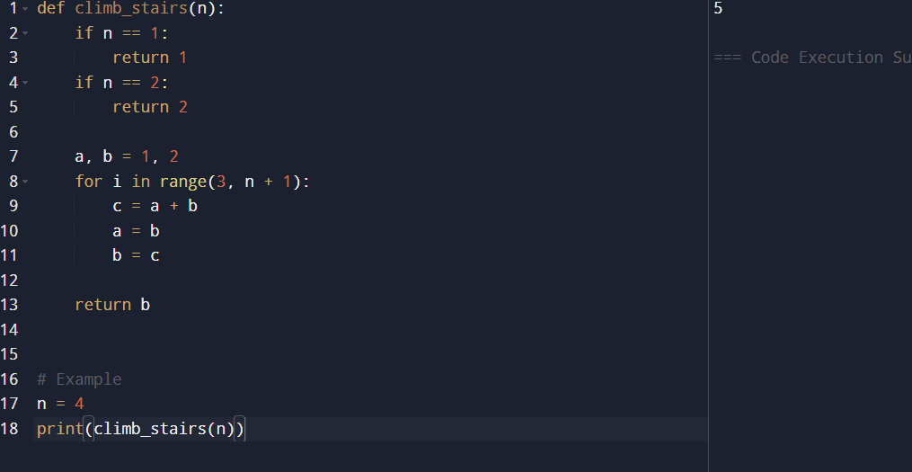

RESULT :
The number of ways follows a Fibonacci pattern, where each step depends on the sum of the previous two steps.

14. A robot is located at the top-left corner of a m×n grid .The robot can only move either down or right at any point in time. The robot is trying to reach the bottom-right corner of the grid. How many possible unique paths are there? Examples: Input: m=7,n=3 Input: m=3,n=2 Output: 28 Output: 3
AIM :
To find the number of unique paths for a robot to move from the top-left corner to the bottom-right corner of an m × n grid, where it can only move right or down.
ALGORITHM :
STEP 1 : Start
STEP 2 : Input values m and n
STEP 3 : Create a 2D array dp[m][n]
STEP 4 : Initialize first row and first column as 1
(since there is only one way to reach those cells)
STEP 5 : For each cell (i, j):
Compute:
dp[i][j] = dp[i-1][j] + dp[i][j-1]
STEP 6 : The value at dp[m-1][n-1] gives total unique paths
STEP 7 : Output the result
STEP 8 : Stop

PROGRAM :
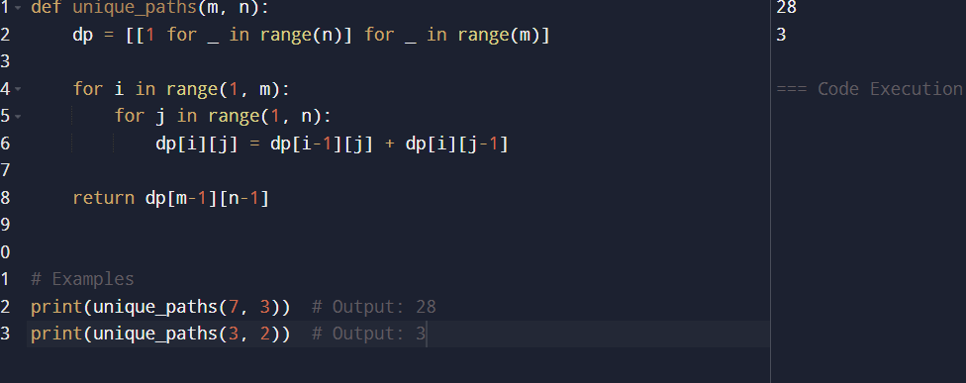

RESULT :
The number of unique paths is found by adding the number of ways from the top cell and left cell, forming a dynamic programming grid.

15. In a string S of lowercase letters, these letters form consecutive groups of the same character. For example, a string like s = "abbxxxxzyy" has the groups "a", "bb", "xxxx", "z", and "yy". A group is identified by an interval [start, end], where start and end denote the start and end indices (inclusive) of the group. In the above example, "xxxx" has the interval [3,6]. A group is considered large if it has 3 or more characters. Return the intervals of every large group sorted in increasing order by start index. Example 1: Input: s = "abbxxxxzzy" Output: [[3,6]] Explanation: "xxxx" is the only large group with start index 3 and end index 6. Example 2: Input: s = "abc" Output: [] Explanation: We have groups "a", "b", and "c", none of which are large groups.

AIM:
To find all large groups (3 or more consecutive same characters) in a string and return their start and end indices.
ALGORITHM :
STEP 1 : Start
STEP 2 : Input the string S
STEP 3 : Initialize an empty list result
STEP 4 : Use a pointer i = 0 to traverse the string
STEP 5 : For each character:
Set j = i
Move j forward while characters are the same
If (j - i) ≥ 3, add [i, j-1] to result
Set i = j and continue
STEP 6 : Return the result list
STEP 7 : Stop
PROGRAM :
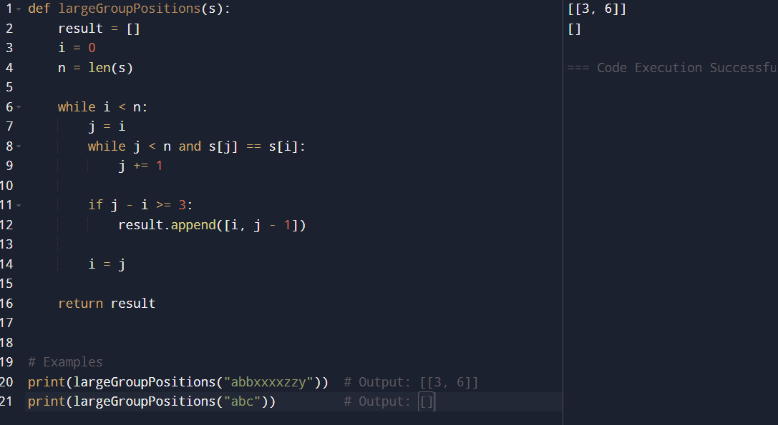

RESULT :
A group is considered large if it has 3 or more consecutive identical characters, and we return their start and end indices.

16. "The Game of Life, also known simply as Life, is a cellular automaton devised by the British mathematician John Horton Conway in 1970." The board is made up of an m x n grid of cells, where each cell has an initial state: live (represented by a 1) or dead (represented by a 0). Each cell interacts with its eight neighbors (horizontal, vertical, diagonal) using the following four rules Any live cell with fewer than two live neighbors dies as if caused by under-population. Any live cell with two or three live neighbors lives on to the next generation. Any live cell with more than three live neighbors dies, as if by over-population. Any dead cell with exactly three live neighbors becomes a live cell, as if by reproduction. The next state is created by applying the above rules simultaneously to every cell in the current state, where births and deaths occur simultaneously. Given the current state of the m x n grid board, return the next state.

AIM:
To compute the next state of the grid based on the rules of the Game of Life, where each cell changes depending on its live neighbors.
ALGORITHM :
STEP 1 : Start
STEP 2 : Input the grid board (m × n)
STEP 3 : For each cell, count the number of live neighbors (8 directions)
STEP 4 : Apply rules:
If a live cell has < 2 or > 3 neighbors → it becomes dead
If a live cell has 2 or 3 neighbors → it stays alive
If a dead cell has exactly 3 neighbors → it becomes alive
STEP 5 : Store results in a new grid (to avoid overwriting)
STEP 6 : Copy new grid to original board
STEP 7 :Output the updated board
STEP 8 :Stop
PROGRAM :
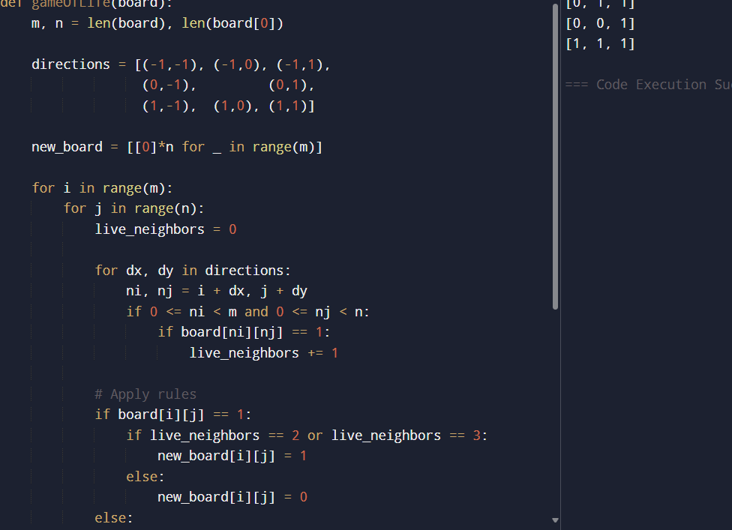

RESULT :
Each cell’s next state depends on its 8 neighbors, and all updates happen simultaneously, producing the next generation of the grid.

17. We stack glasses in a pyramid, where the first row has 1 glass, the second row has 2 glasses, and so on until the 100th row. Each glass holds one cup of champagne. Then, some champagne is poured into the first glass at the top. When the topmost glass is full, any excess liquid poured will fall equally to the glass immediately to the left and right of it. When those glasses become full, any excess champagne will fall equally to the left and right of those glasses, and so on. (A glass at the bottom row has its excess champagne fall on the floor.) For example, after one cup of champagne is poured, the top most glass is full. After two cups of champagne are poured, the two glasses on the second row are half full.

AIM:
To find how much champagne is in a specific glass after pouring a given number of cups into a pyramid of glasses.

ALGORITHM:
STEP 1 : Start
STEP 2 :Input:
poured (total cups poured)
query_row
query_glass
STEP 3 : Create a 2D array dp[101][101] initialized to 0
STEP 4 : Set dp[0][0] = poured
STEP 5 : For each row i from 0 to 100:
For each glass j from 0 to i:
If dp[i][j] > 1:
Overflow = (dp[i][j] - 1) / 2
dd overflow to:
dp[i+1][j]
dp[i+1][j+1]
STEP 6 : The value in each glass cannot exceed 1
STEP 7 : Return min(1, dp[query_row][query_glass])
STEP 8 : Stop
PROGRAM :
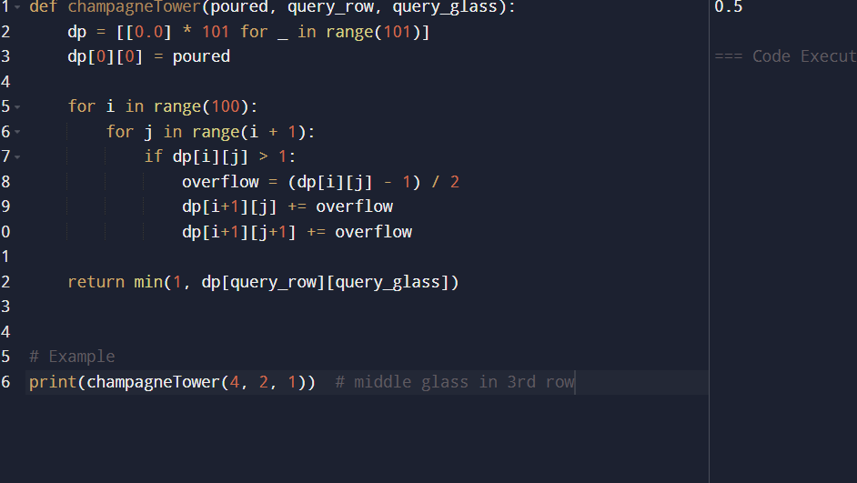
RESULT :
Champagne flows down the pyramid by splitting equally between two glasses. Each glass can hold only 1 cup, and extra liquid is passed downward, forming a dynamic flow pattern.

